**Steven Taylor**

**November 28, 2021**

**Predictive Analytics & Forecasting**

**Homework Assignment 2**

**Chapter 7**

* 1. The optimal values of alpha and level are 0.2971 (alpha) and 77260.0561 (level).

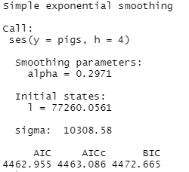

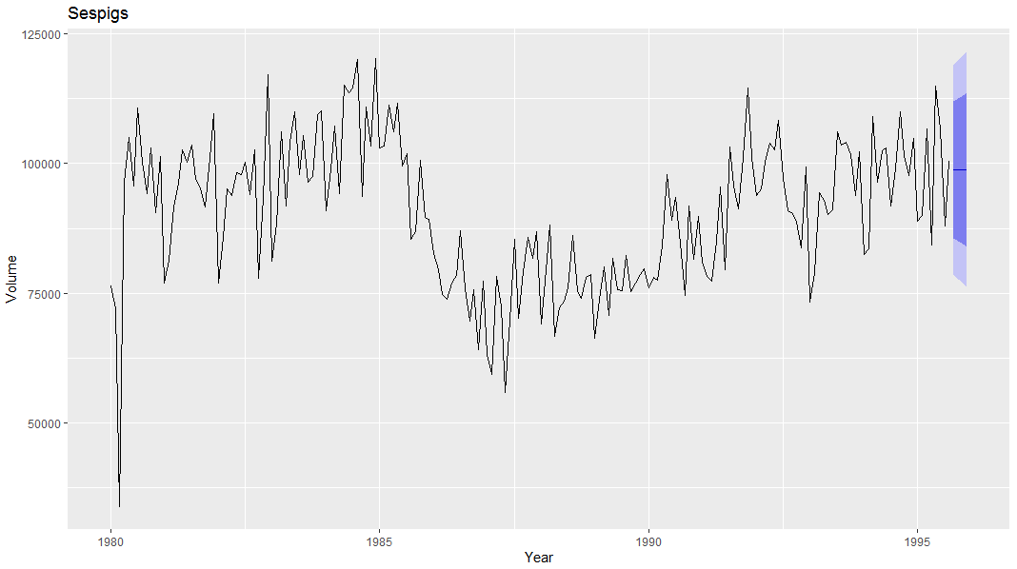

* 1. The 95% intervals R produces are 119,021 and 78,612. The 95% intervals our model produces are 118,953 and 78,680. It appears our bands are slightly tighter to the mean then the upper and lower bands produced by R.

1. Our forecast using the ses function was horizontal and had wide confidence intervals. I chose to update the forecast using a stlf function. The resulting forecast is below. You will notice this forecast remains horizontal but adds ebbs and flows to the forecast.

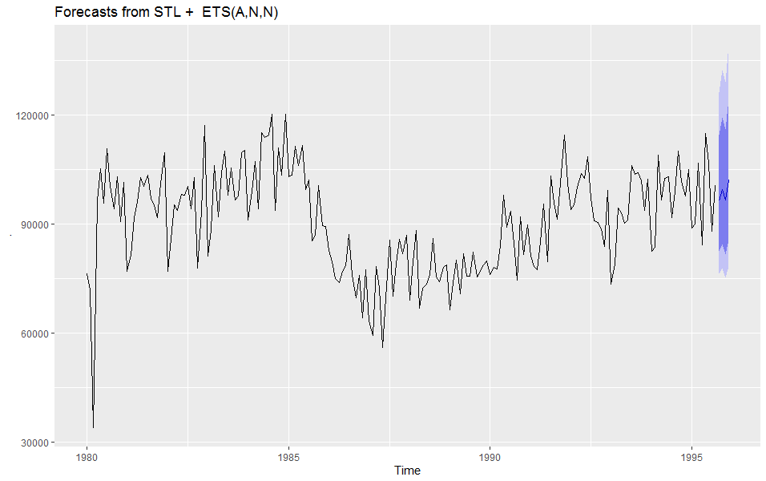

1. The squared residuals of sespigs is 10,273.69. I’m not able to pull residuals for my updated model.
2. Optimal value for alpha = .2971. Optimal value for level = 77260.
   1. Plot book data

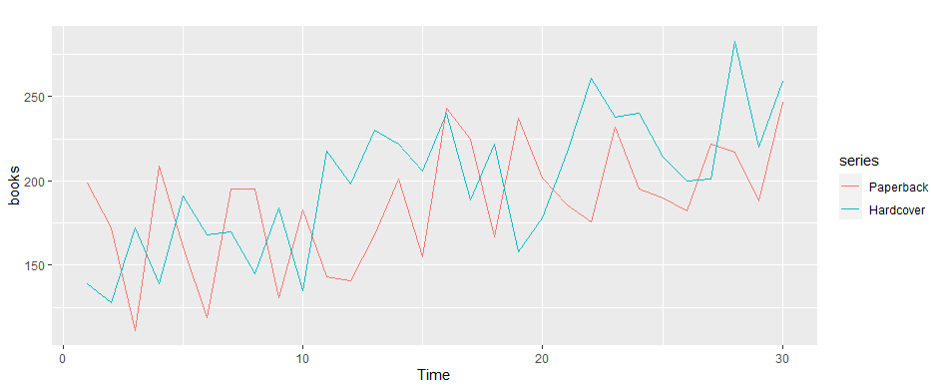

* 1. Forecast both series.

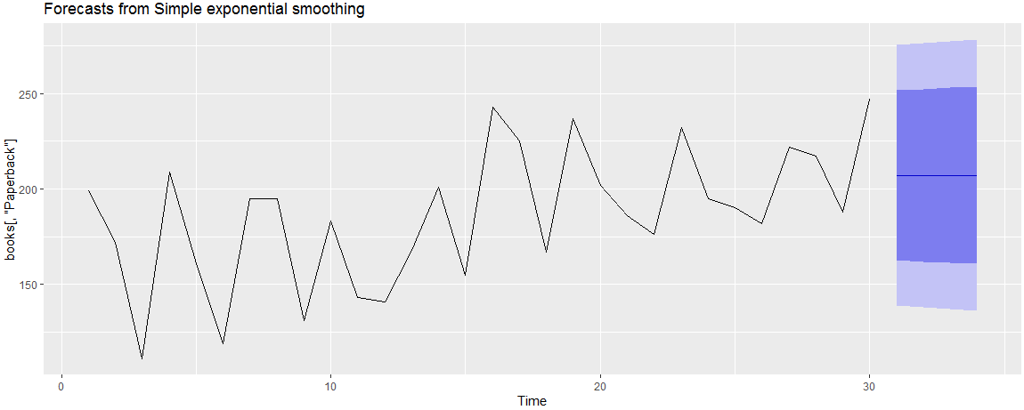

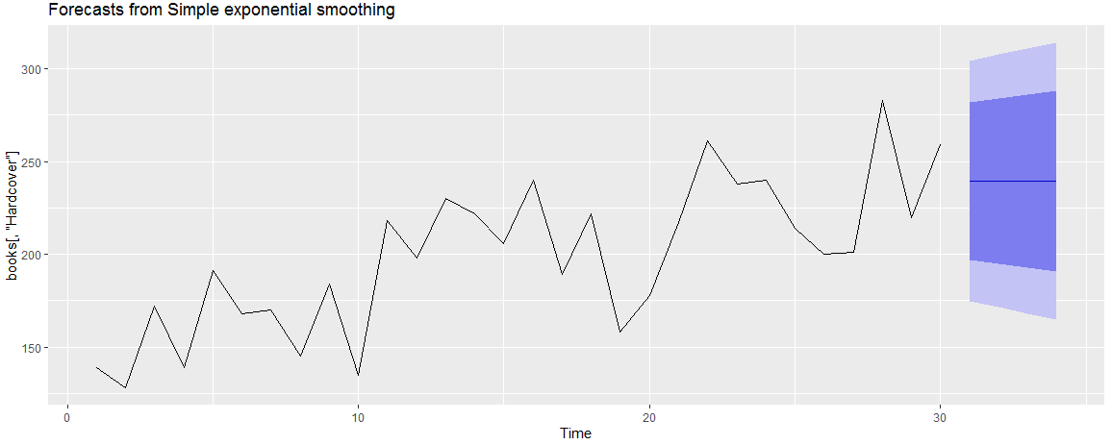

* 1. The RMSE for our paperback data is 33.63769 while the RMSE for our hardcover data is 31.93101.
  2. Paperback sales are expected to reach 213.2197 after four days while hardcover sales are expected to reach 260.0817.

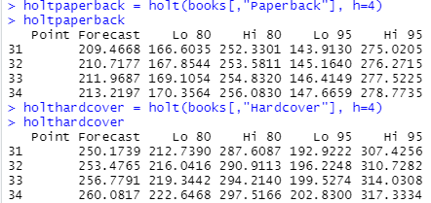

* 1. Simple exponential smoothing is best for forecasting data with no clear trend or seasonal pattern. To the contrary, Holts-Winters’ seasonal method is designed to capture seasonality. These are two similar tools that are best utilized on different types of time series data.
  2. Holt paperback RMSE 31.13692 while the Holt hardcover RMSE is 27.19358. The Holt method performs better as it has a lower RMSE than our ses method.
  3. Holt paperback 95% upper is 275.0205; lower is 143.913.

Holt hardcover 95% upper is 307.4256; lower is 192.9222.

When I compare these bands to the sqrt bands I find that the sqrt bands tend to be about 5 points tighter.

Holt forecast with no dampening: We see a slight downward trend, in line with the current trajectory.

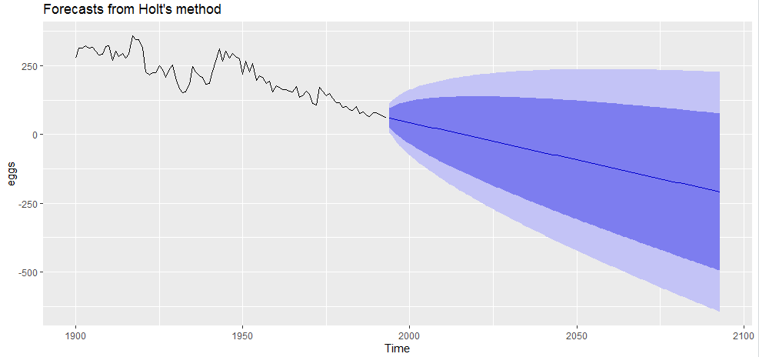

Holt forecast with dampening: The forecast flattens and has wide bands.

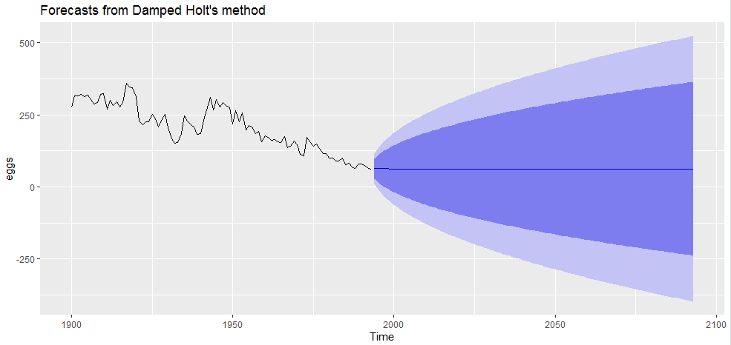

Holt forecast with dampening and exponential variable equal to true: We see a flat forecast with a firm floor and wide ranging upward potential.

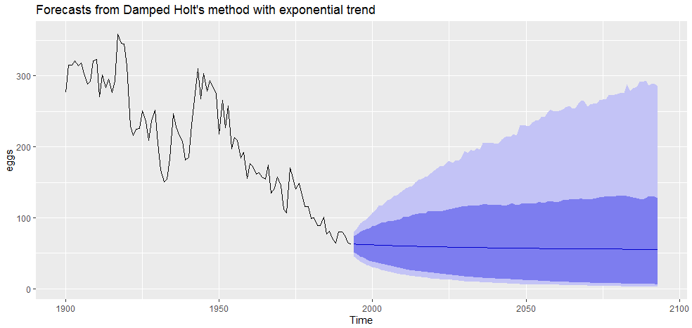

Holt forecast without dampening and exponential variable equal to true: We see a confident forecast with tight bands. The trend continues downward but at a slower rate. The trend eventually flattens. This model has the lowest RMSE.

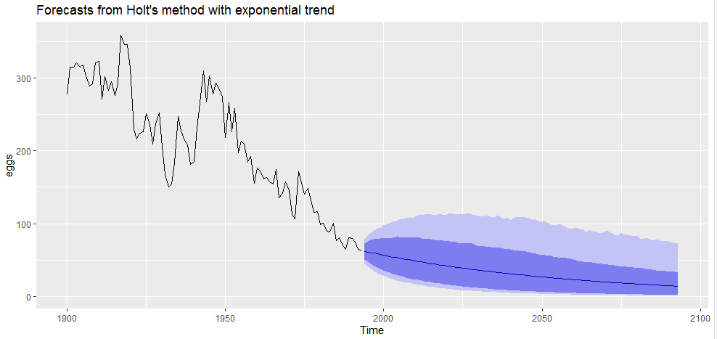

* 1. x
  2. X
  3. X
  4. X
  5. x

1. N/A
   1. The ukcars data appears to have short term volatility but follows a longer term, upward trend.

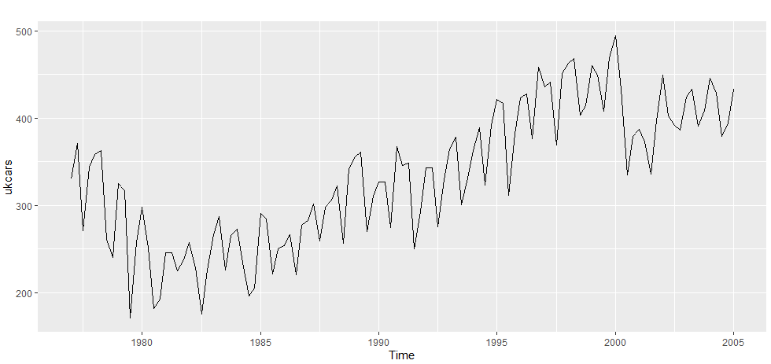

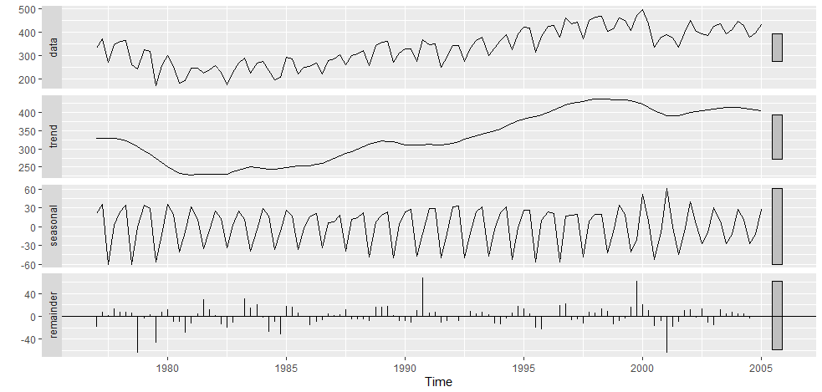

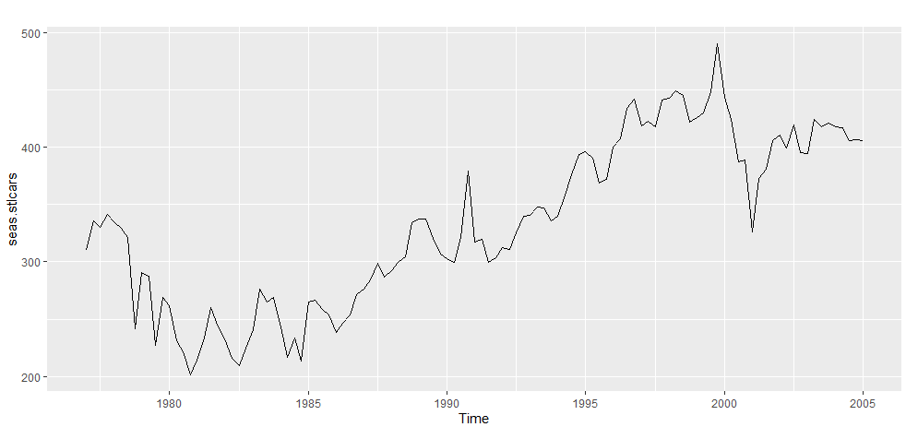

* 1. Additive damped trend method applied to the seasonally adjusted data:

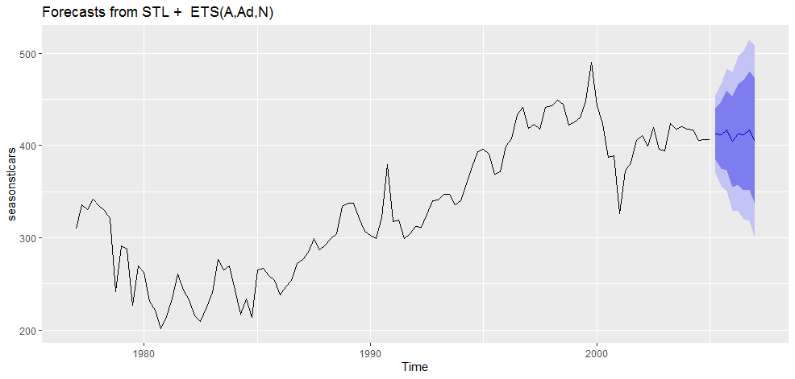

* 1. Holt’s linear method applied to the seasonally adjusted data:

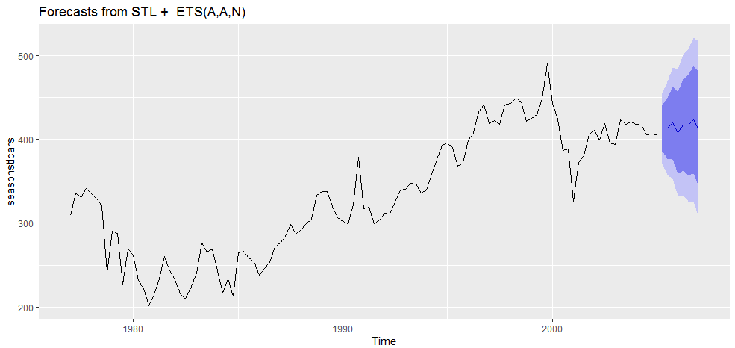

* 1. ETS

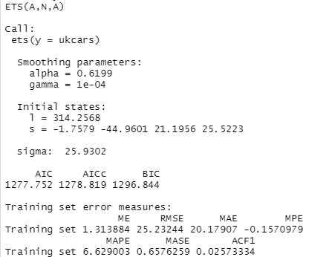

* 1. RMSE is lowest with the additive dampened stl model.

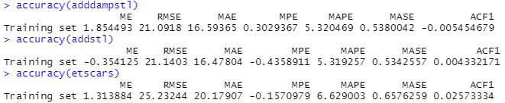

* 1. Its difficult to compare the models because each of them seems reasonable.





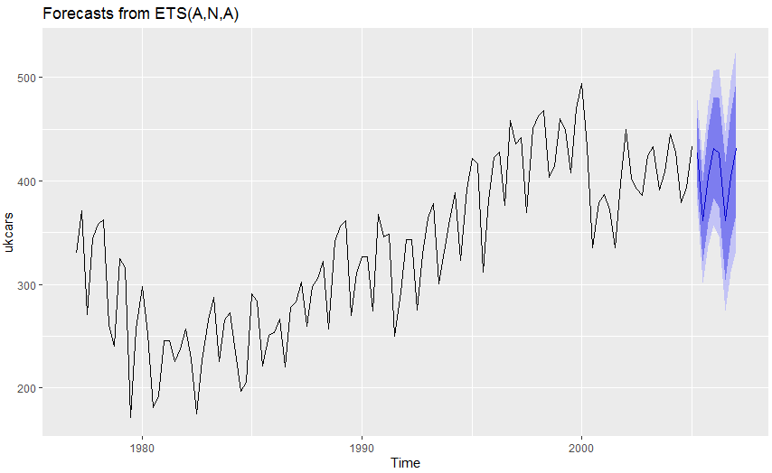

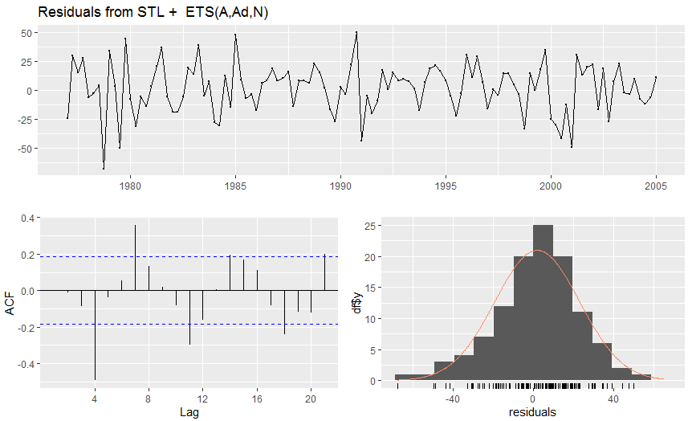

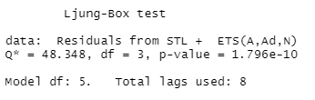

* 1. Short term volatility but consistently moving in an upward trend.

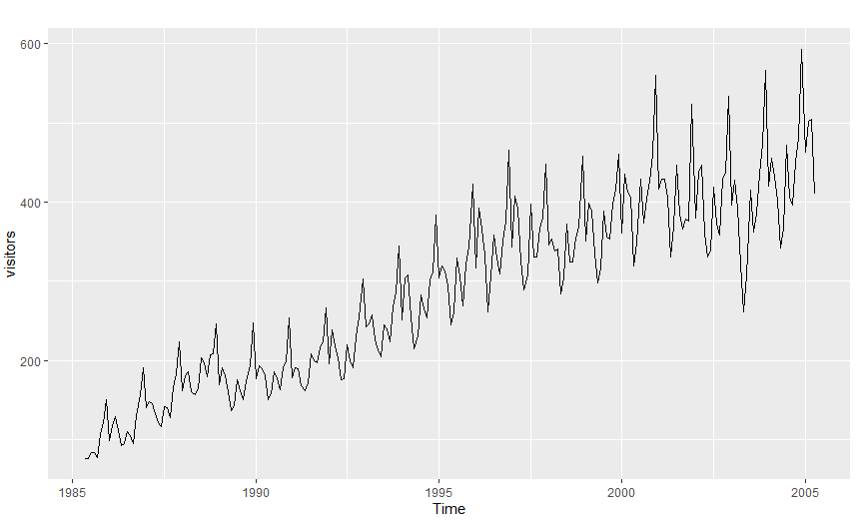

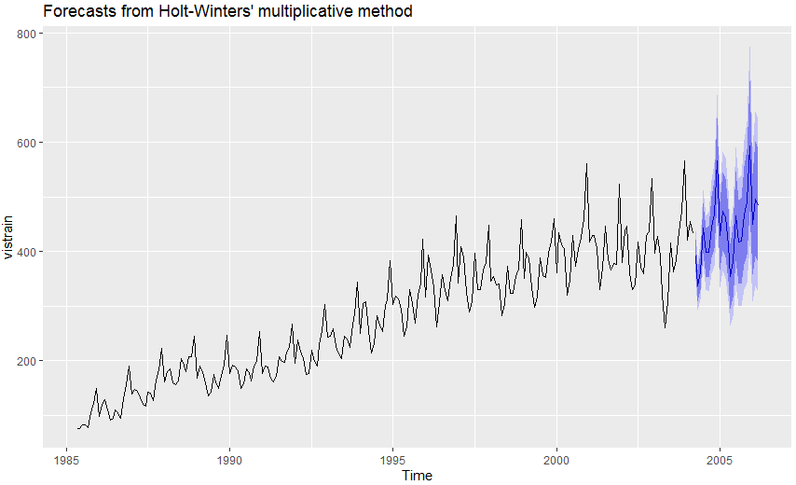

* 1. We have to use multiplicative seasonality here due to the nature of the data being seasonal. Further, we see volatility as the data increases in volume.
     1. ETS

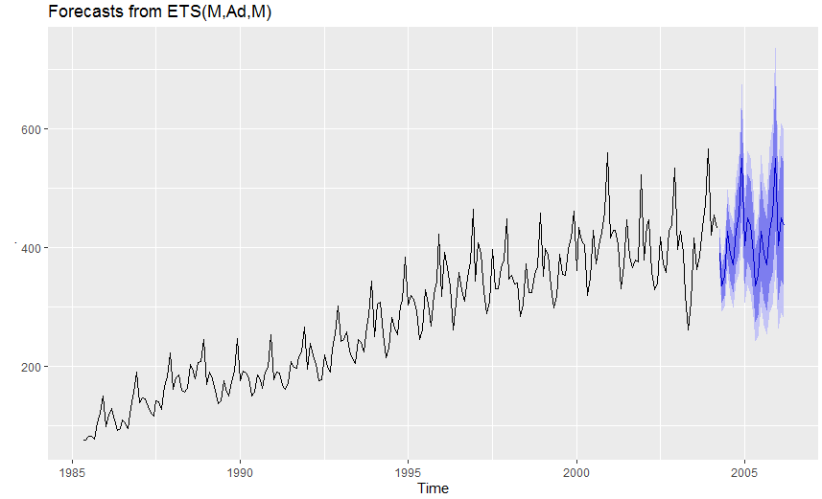

* + 1. Additive ETS to Box Cox

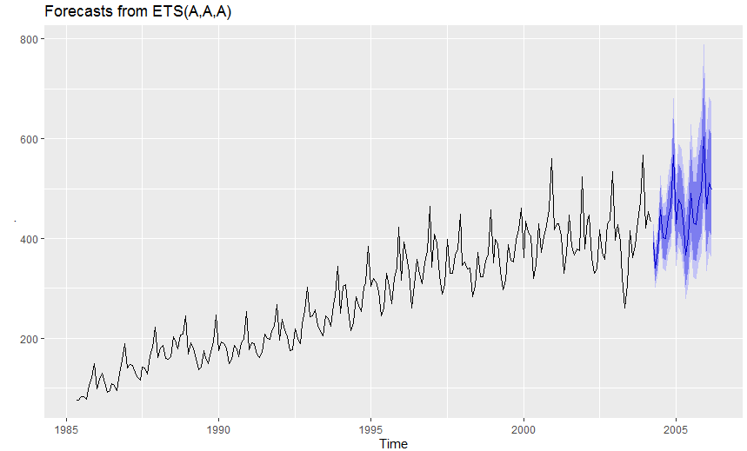

* + 1. Seasonal naïve

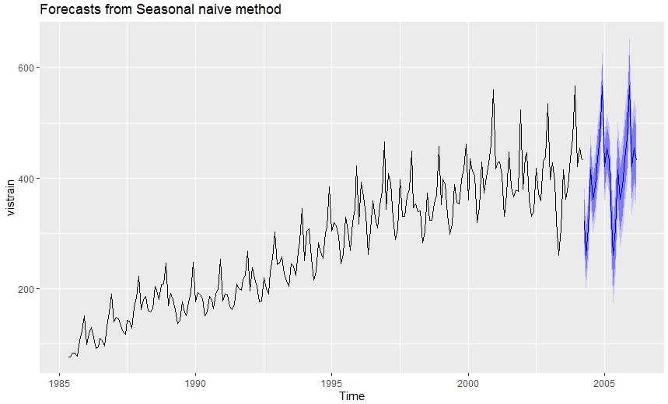

* + 1. STL

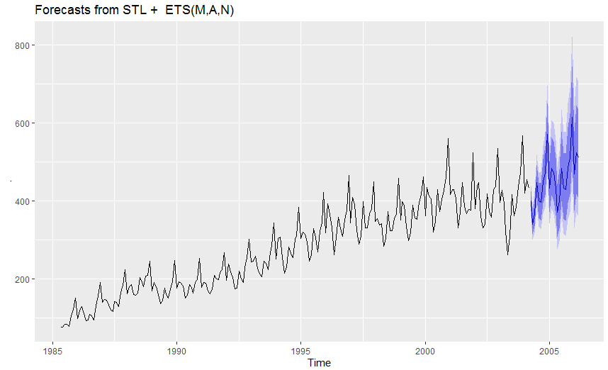

* 1. The lowest RMSE came from our Box Cox transformation stl decomposition ets model.

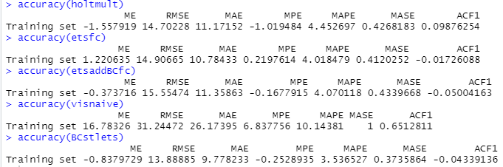

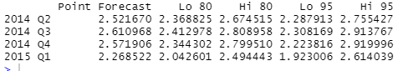

mean(fets^2, na.rm = TRUE)

Error in fets^2 : non-numeric argument to binary operator

Chapter 8

* 1. There are two clear differences between the three images. The first change is the graphed ACF levels (or dotted blue lines) tighten as our n increases. I also notice the ACF spikes are not aligning from image to image. This indicates the model changing as more data become available.
  2. We expect each autocorrelation to be close to zero. Different spikes indicate different variables are being flagged as potential white noise data.

1. The ACF plot shows autocorrelation as nearly every spike is above our threshold. The PACE plot only shows one instance of autocorrelation.

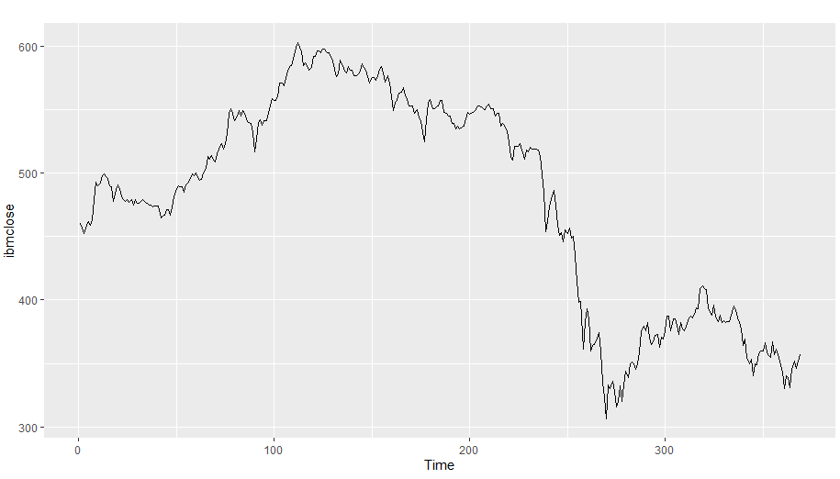

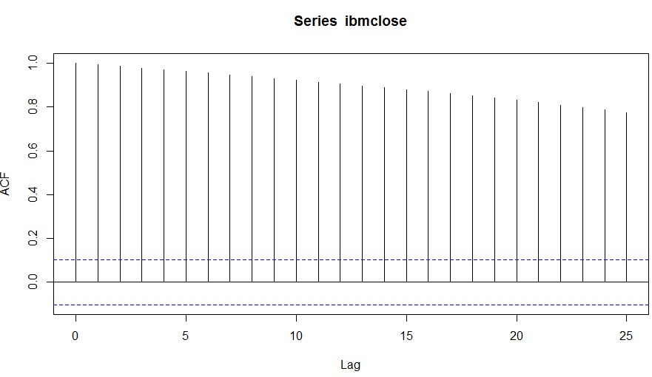

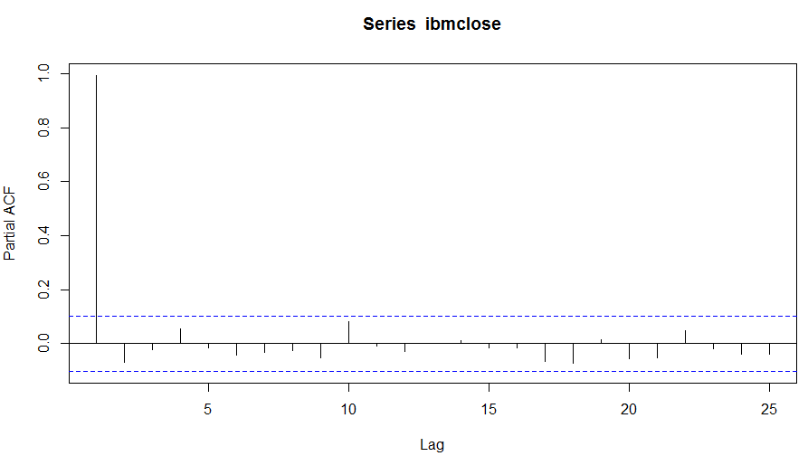

* 1. Usnetelec: lam=.5168

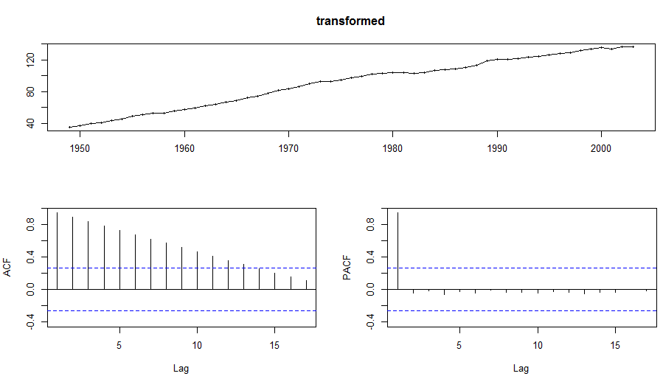

* 1. Usgdp: lam = .3664

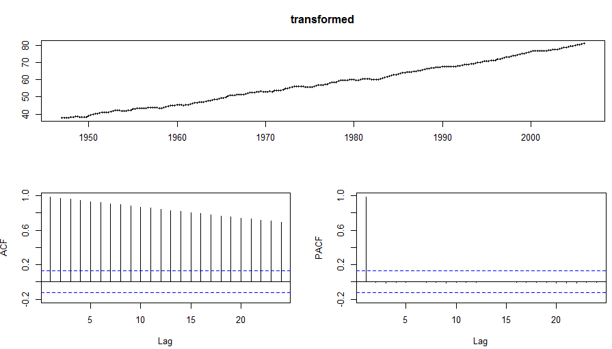

* 1. Mcopper: lam = .1919

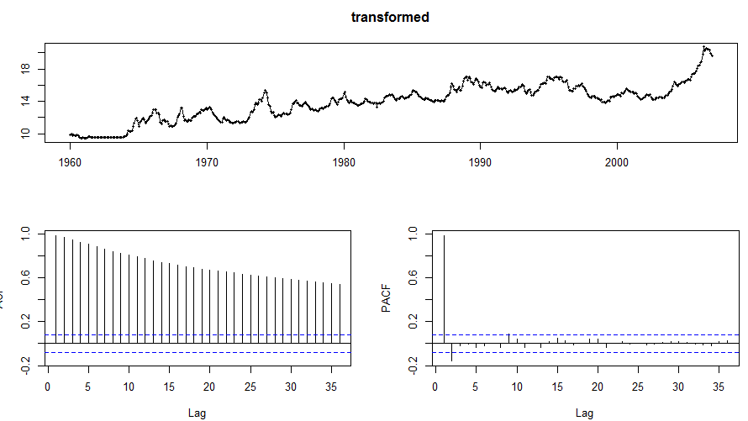

* 1. Enplanements: lam = -.2269

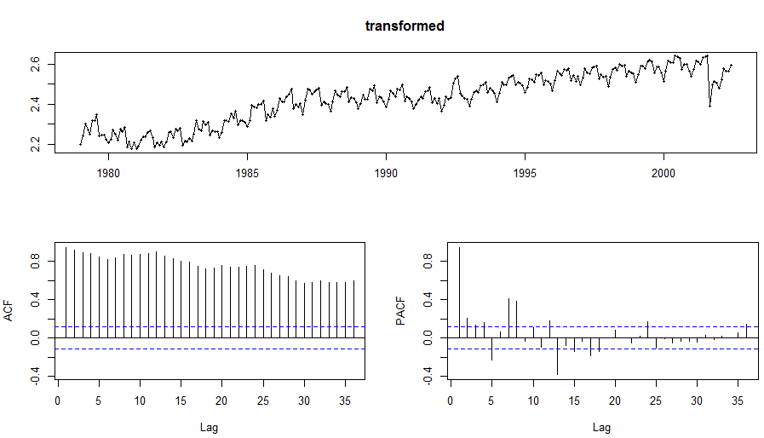

* 1. Visitors: lam = .2775

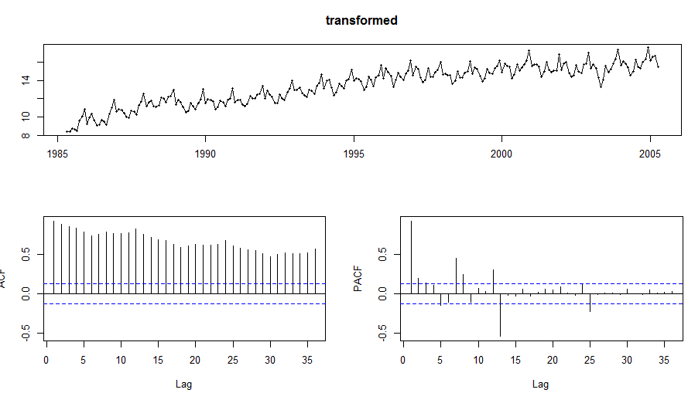

1. No retail data
2. No retail data
3. x
   1. This plot does not change over time.

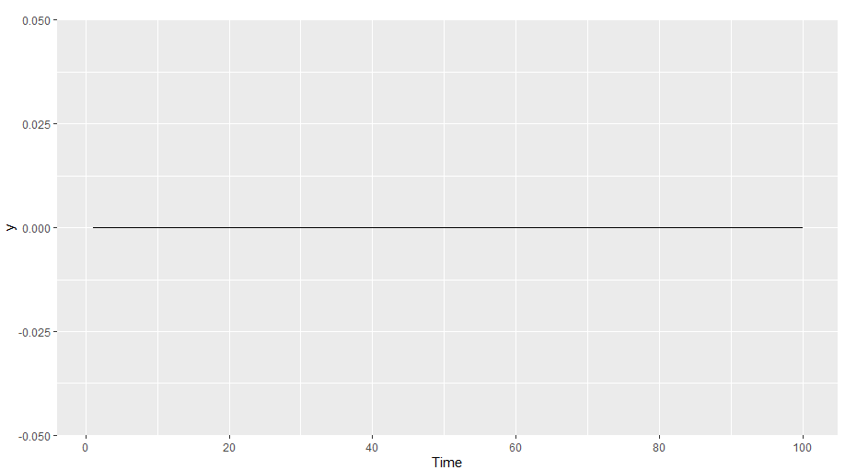

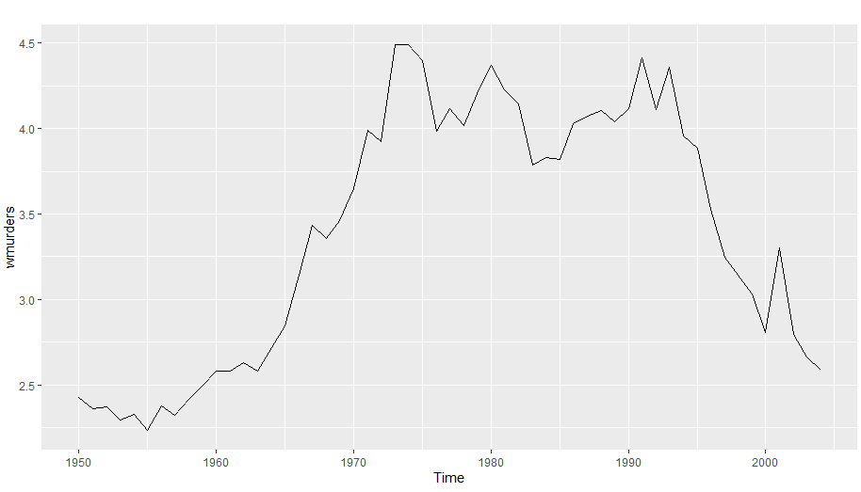

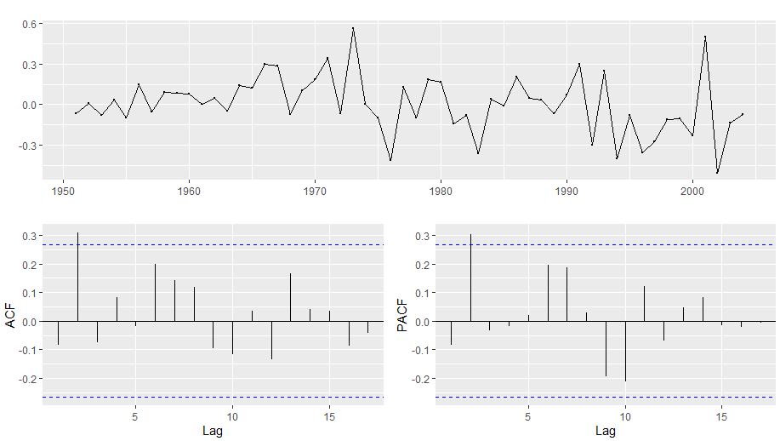

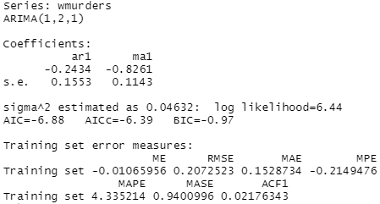

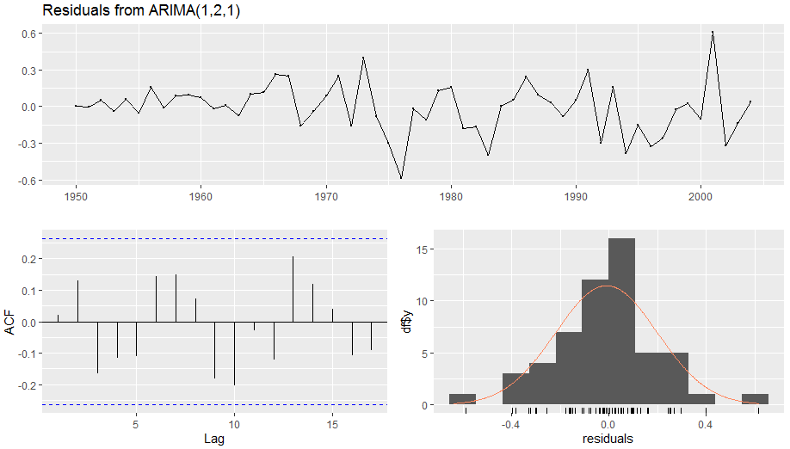

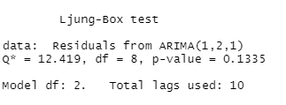

* 1. No. This may introduce a drift.
  2. N/A
  3. Yes. The Arima model is satisfactory.



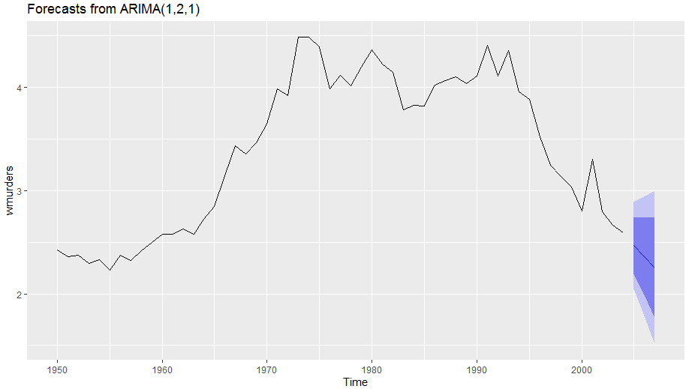

* 1. Same model.

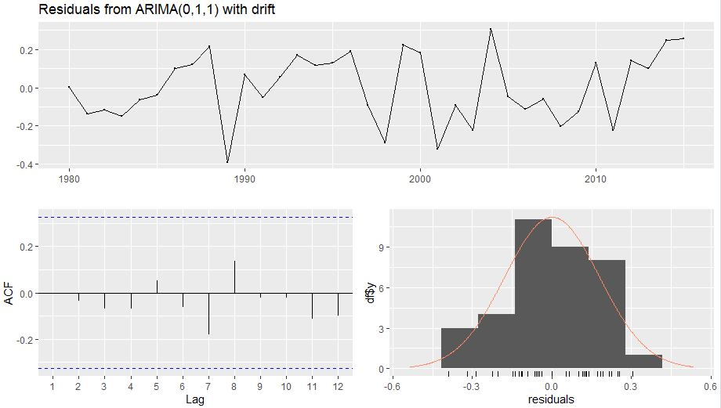

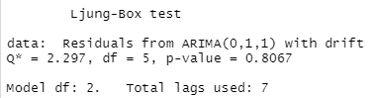

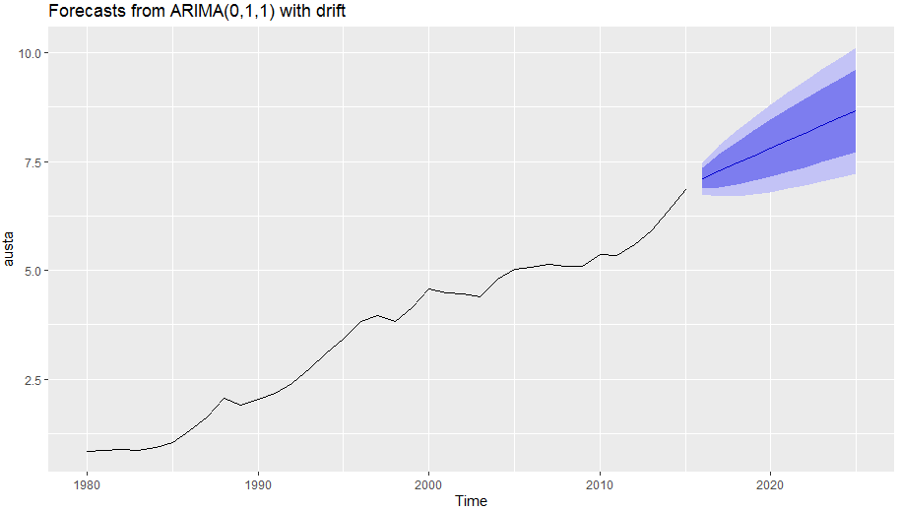

* 1. When the drift is removed we see a flattening of the forecast.

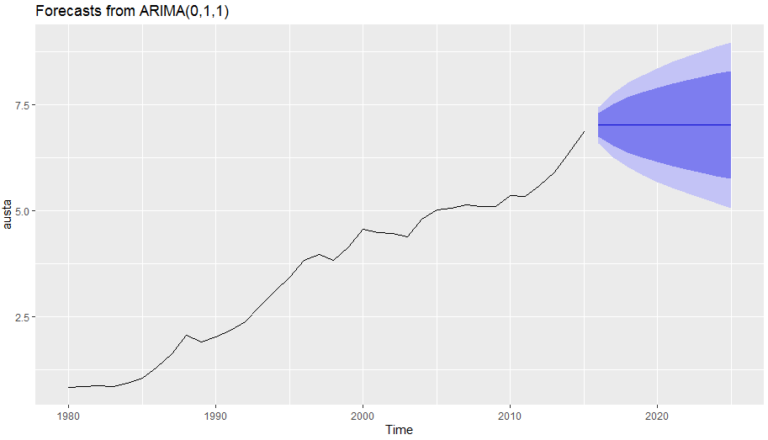

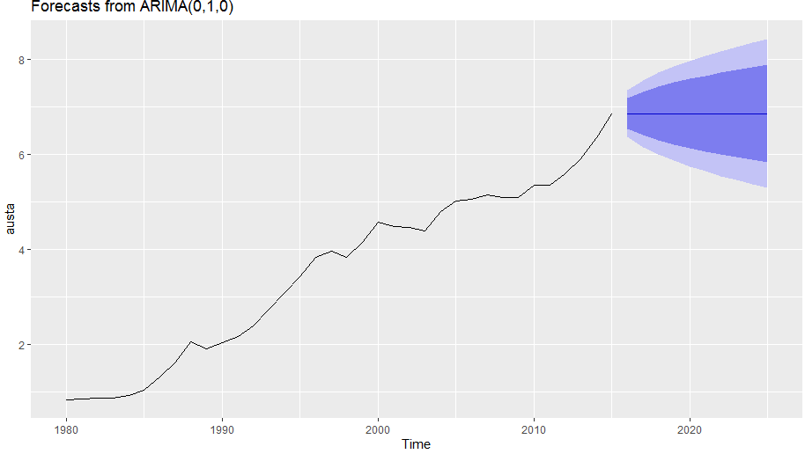

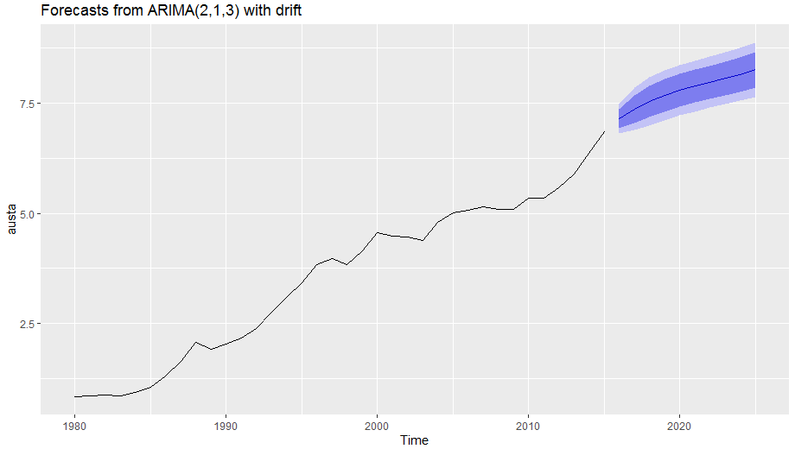

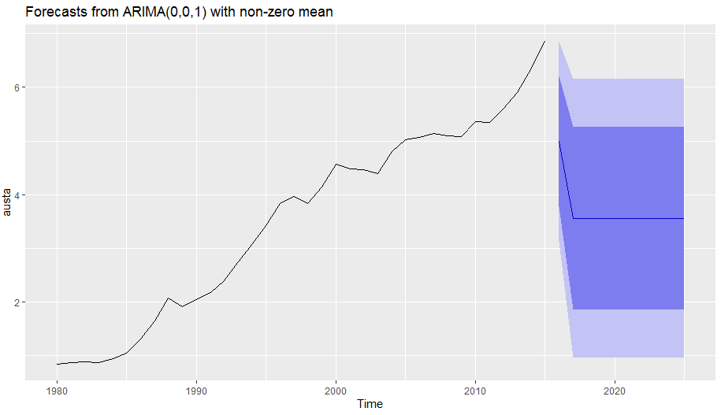

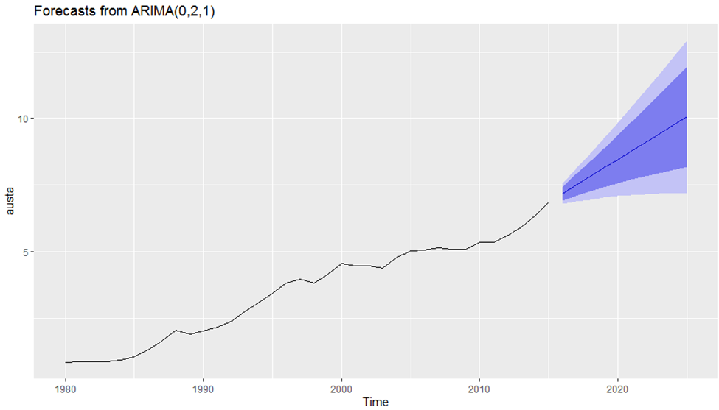

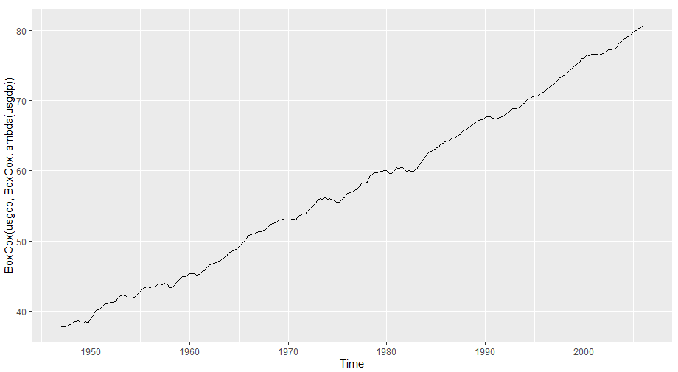

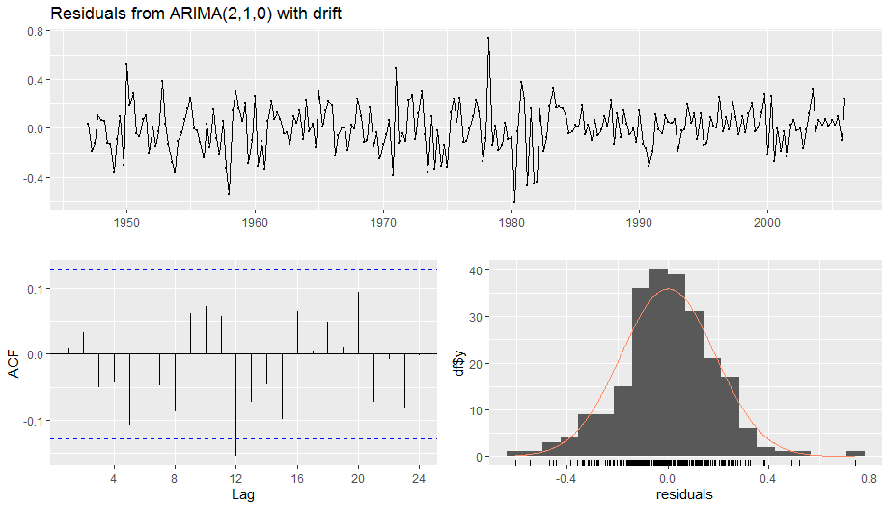

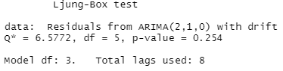

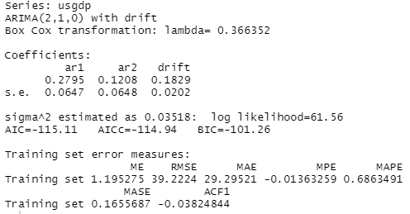

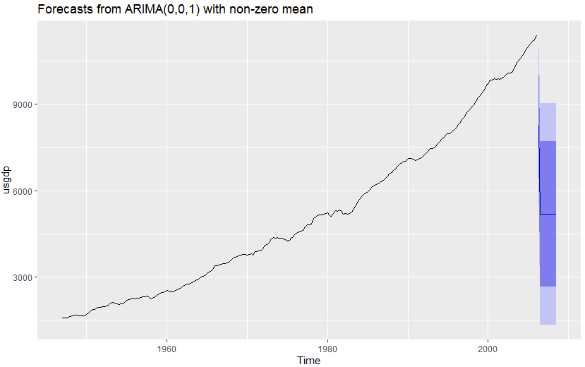

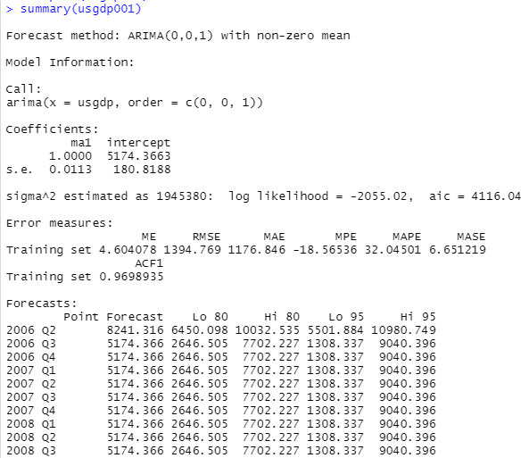

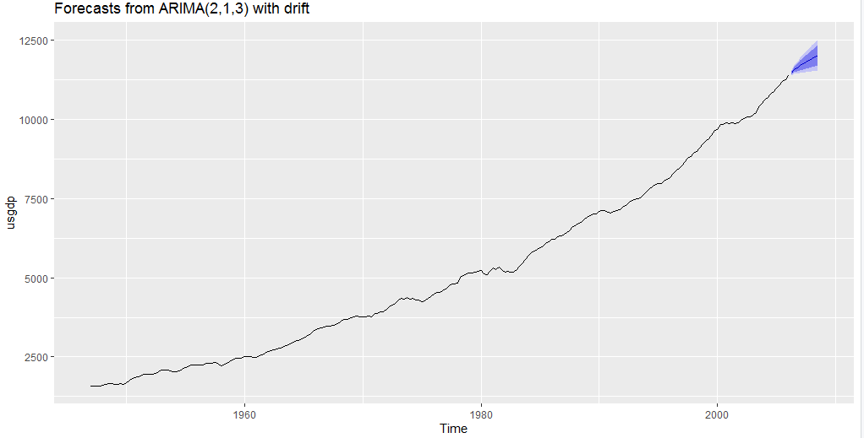

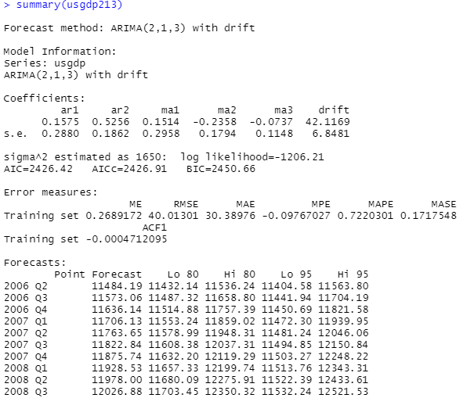

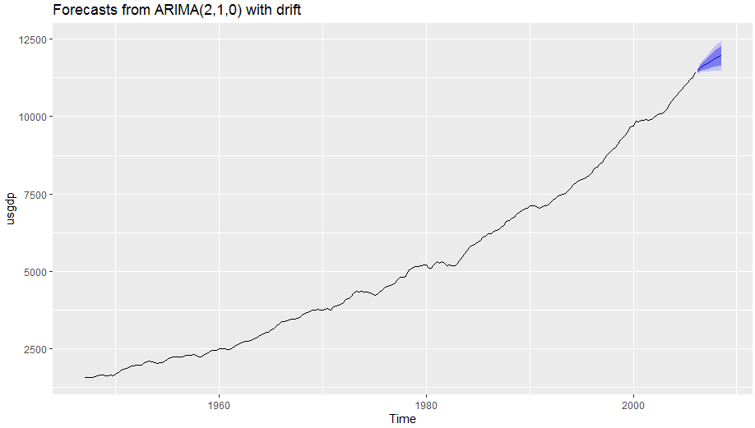

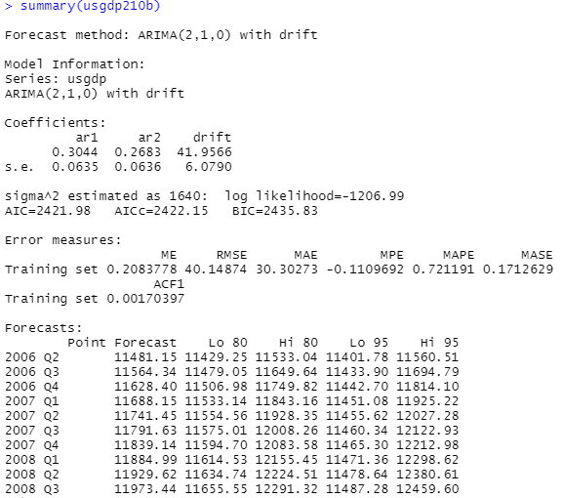

* 1. The model with the lowest RMSE is ASRIMA 2,1,3 with drift. The RMSE was 40.14874.

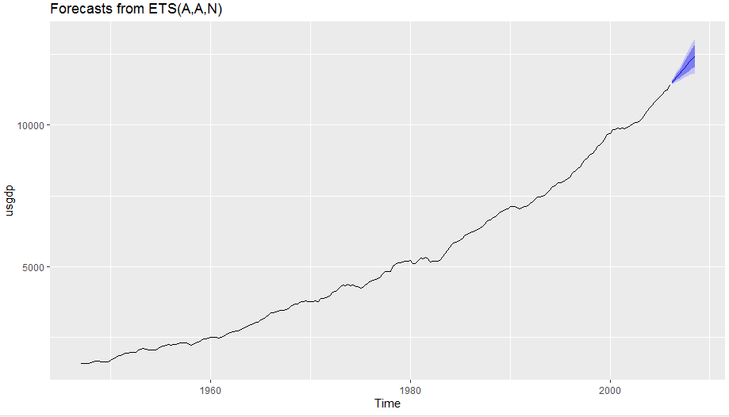

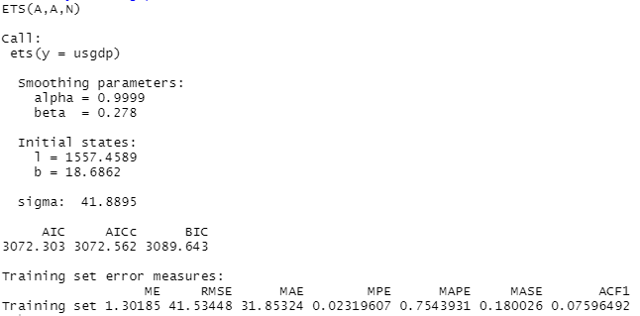

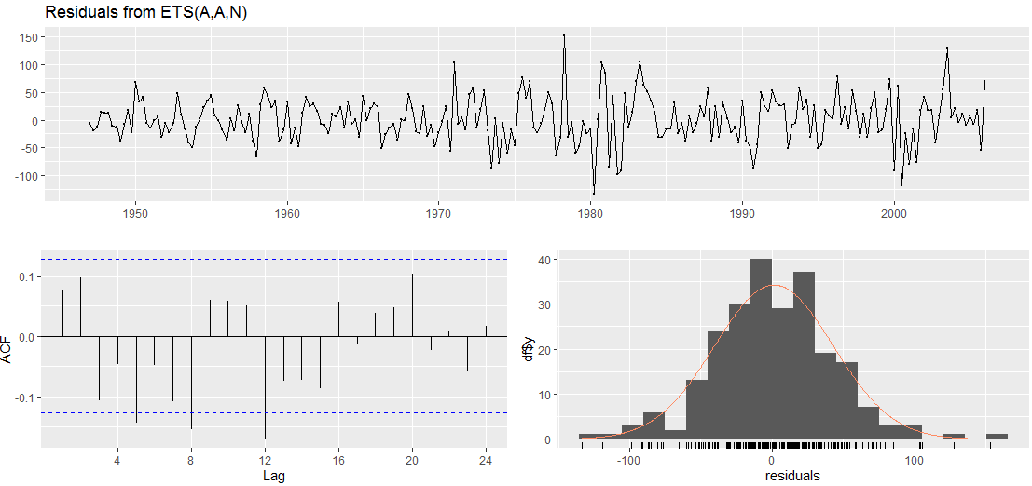

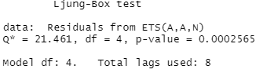

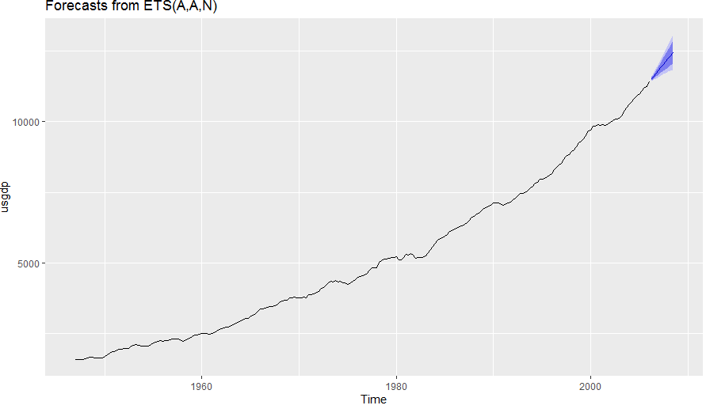

1. This data is seasonal and trending upward.

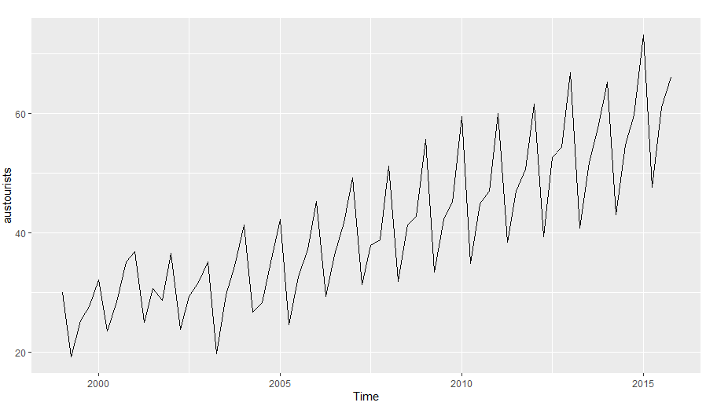

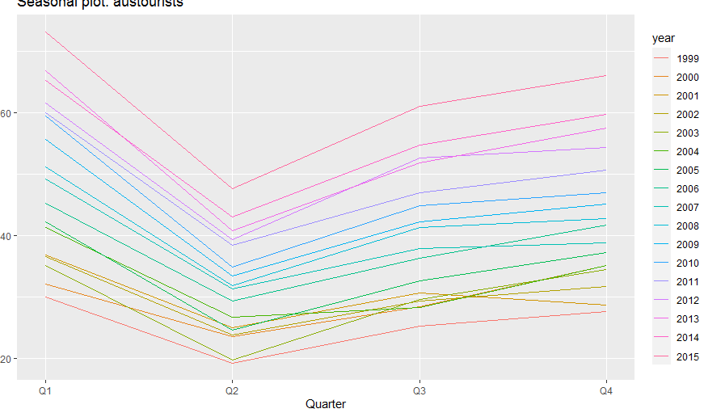

* 1. The autocorrelations decrease over time.

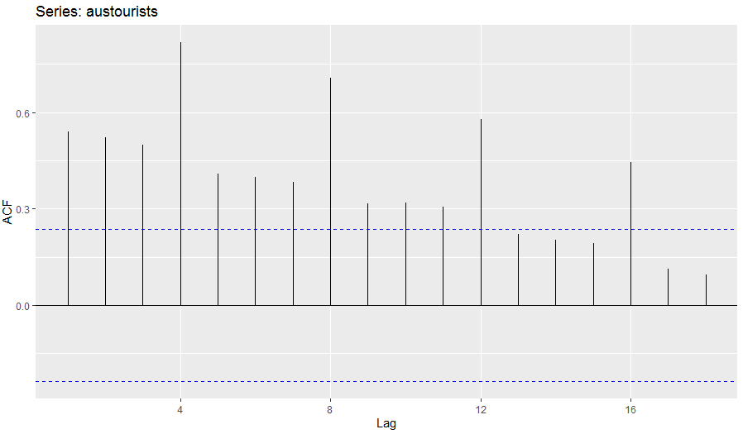

* 1. Autocorrelations decrease over time.

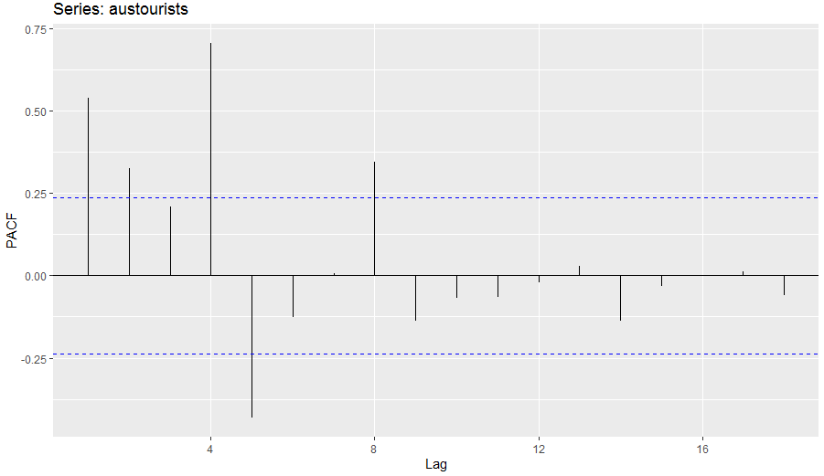

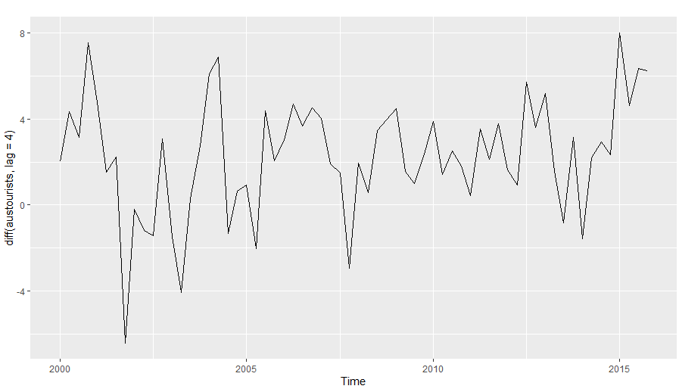

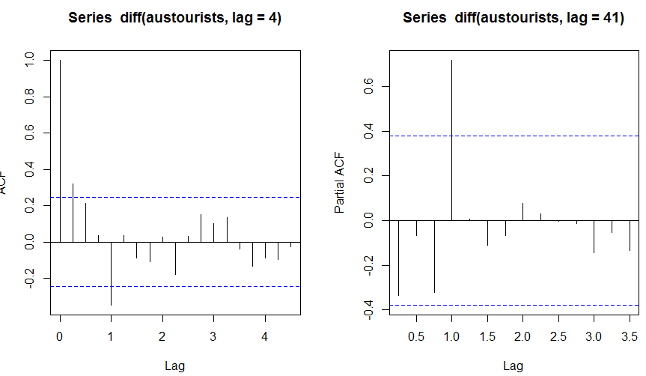

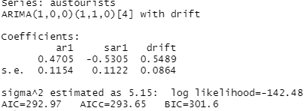

* 1. Strong upward trend with no seasonality.

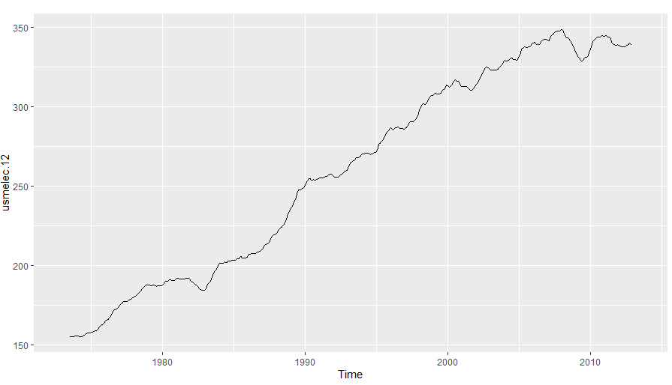

* 1. Box cox transformation

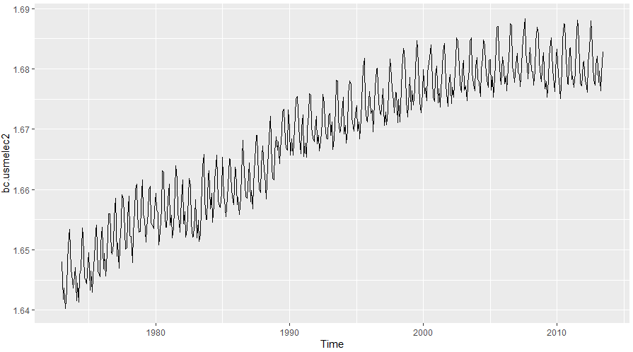

* 1. The data is not stationary.



Model 1:

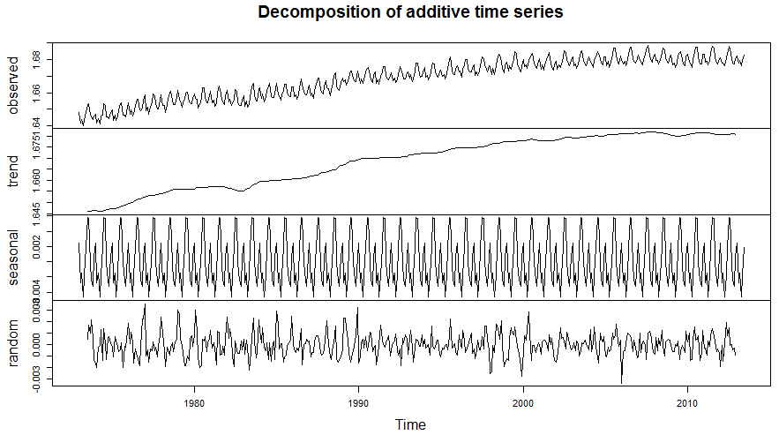

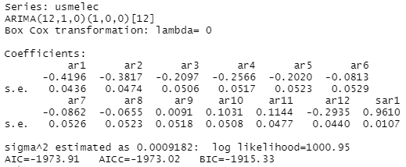

Model 2:

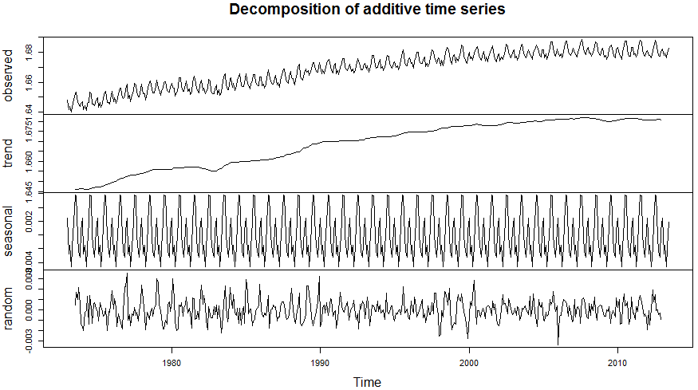

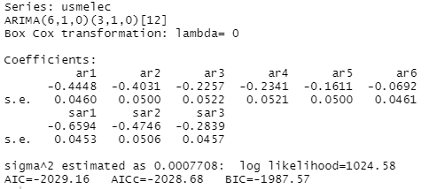

Model 1:

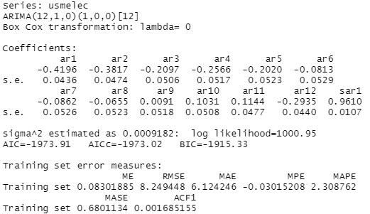

Model 2:

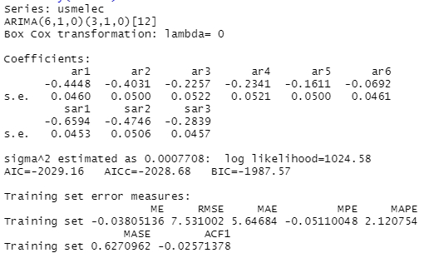

* 1. These residuals do not indicate white noise.

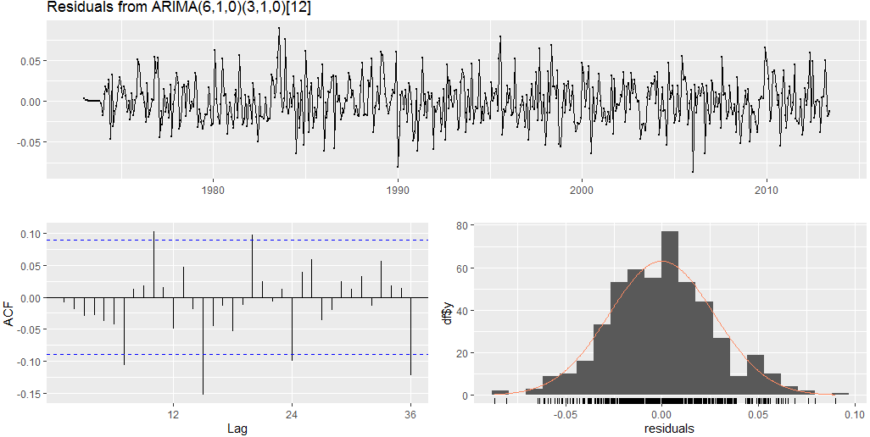

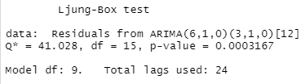

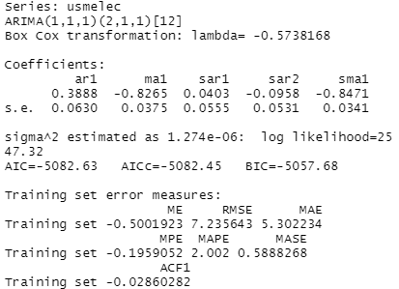

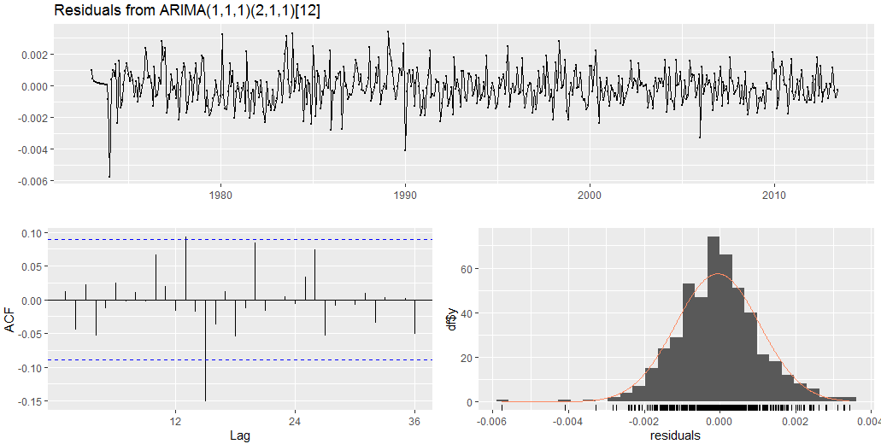

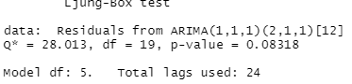

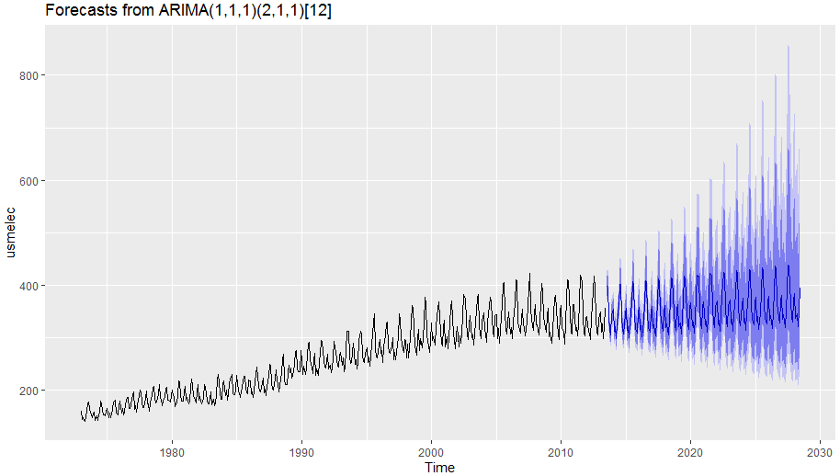

* 1. The forecast gets too wide as the time horizon is further out. The forecast looks reasonable for roughly four to five years from the end of the data.

1. X
2. x
3. X
4. X
5. X
6. X
7. X
8. X
9. X
10. X
11. x